1. CFY Introduction to Networking Lab Exam [80 Minutes]

|  |  |  |  |
| --- | --- | --- | --- |
| **Student Name** |  | **Lab Instructor** | **Kevin Conway** |
| **Student ID** |  | **Final Marks (/100)** |  |
| **Student Group** |  |  |  |
| **Date/Time** |  |  |  |

**Instructions:**

* **Duration: 80 minutes**
* Use Packet Tracer
* Label all devices clearly & put your name/ID in PT file
* Save your configuration

1. Topology

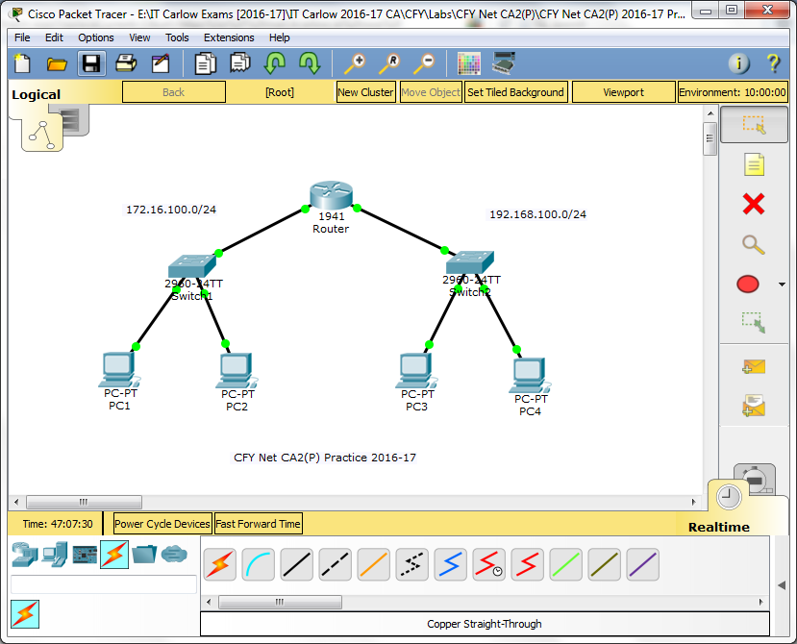

1. Addressing Table

|  |  |  |  |  |
| --- | --- | --- | --- | --- |
| **Device** | **Interface** | **Address** | **Subnet Mask** | **Default Gateway** |
| Router | G0/0 | 172.16.100.1 | 255.255.255.0 | N/A |
| G0/1 | 192.168.100.1 | 255.255.255.0 | N/A |
| Switch1 | VLAN 1 | 172.16.100.2 | 255.255.255.0 |  |
| Switch2 | VLAN 1 | 192.168.100.252 | 255.255.255.0 |  |
| PC1 | NIC | 172.16.100.11 | 255.255.255.0 |  |
| PC2 | NIC | 172.16.100.12 | 255.255.255.0 |  |
| PC3 | NIC | 192.168.100.12 | 255.255.255.0 |  |
| PC4 | NIC | 192.168.100.13 | 255.255.255.0 |  |

1. Passwords

|  |  |  |
| --- | --- | --- |
| Device | Security Type | Password |
| Switch1, Switch2, Router | All | **cisco/cisco1** |

1. Assessment Objectives

Part 1: Complete Addressing Table & Cable Network (20 points)

Part 2: Configure Switch (30 points)

Configure switch name & disable domain lookup

Secure access to all configuration lines of the switch

Secure access to the device configurations of the switch using the encrypted password

Ensure that all plain text passwords on the switch are encrypted.

Configure an appropriate banner on the switch

Configure addressing for all devices according to the Addressing Table. Most values are provided in the table, others you must determine

Document interfaces with descriptions on the switch virtual interface

Part 3: Configure Router (25 points)

Configure addressing for all devices according to the Addressing Table

Secure access to all configuration lines of the router

Secure access to the device configurations of the router using the encrypted password

Ensure that all plain text passwords on the router are encrypted.

Configure an appropriate banner on the router

Document interfaces with descriptions on the router interfaces

Part 4: Configure PCs (10 points)

Configure addressing for PCs according to the Addressing Table. Most values are provided in the table, others you must determine

Part 5: Test Network (15 points)

Verify connectivity between all devices. All devices should be able to ping all of the other devices.

**Troubleshoot any connectivity problems.**

1. Scenario

In this Skills Assessment (SA) you will configure the devices in a small network. You must configure router, switches and PCs to support IPv4 connectivity. You will configure security on the devices. You will test and document the network using common CLI commands. Finally, you will save the router configuration to NVRAM.

1. Required Resources

* 1 Router (Cisco 1941)
* 2 Switches (Cisco 2960)
* 4 PCs
* Console cable to configure the Cisco IOS devices via the console ports
* Ethernet cables as shown in the topology

1. Complete Addressing Table & Cable Network

* Complete the Addressing Table:

**Total points: 12 = 6x2**

|  |  |  |  |  |
| --- | --- | --- | --- | --- |
| **Device** | **Interface** | **Address** | **Subnet Mask** | **Default Gateway** |
| Router | G0/0 | 172.16.100.1 | 255.255.255.0 | N/A |
| G0/1 | 192.168.100.1 | 255.255.255.0 | N/A |
| Switch1 | VLAN 1 | 172.16.100.2 | 255.255.255.0 |  |
| Switch2 | VLAN 1 | 192.168.100.252 | 255.255.255.0 |  |
| PC1 | NIC | 172.16.100.11 | 255.255.255.0 |  |
| PC2 | NIC | 172.16.100.12 | 255.255.255.0 |  |
| PC3 | NIC | 192.168.100.12 | 255.255.255.0 |  |
| PC4 | NIC | 192.168.100.13 | 255.255.255.0 |  |

* Cable the network:

**Total points: 8 = (Router=2, Switches/PCs=6x1)**

**Instructor Sign-off Part 1: _____________**

Part 2: Configure the Switch

**Total points: 30**

* Configure both switches
* Configure switch with name given in addressing table & disable domain lookup
* Secure access to all configuration lines of the switch
* Secure access to the device configurations of the switch using the encrypted password
* Ensure that all plain text passwords on the switch are encrypted.
* Configure an appropriate banner on the switch
* Configure addressing for all devices according to the Addressing Table. Most values are provided in the table, others you must determine
* Document interfaces with descriptions on the switch virtual interface

|  |  |  |  |
| --- | --- | --- | --- |
| Task | Specification | IOS Commands | Points (30) |
| Config switch name | S1/S2 |  | (3 points) |
| Disable DNS | S1/S2 |  | (3 points) |
| Secure access to switch | S1/S2 |  | (14 points) |
| Encrypt text password | S1/S2 |  | (3 points) |
| Config banner | S1/S2 |  | (2 points) |
| Config switch interface | S1 |  | (3 points) |
| Config switch interface | S2 |  | (3 points) |
| Document switch interfaces | S1/S2 |  | (3 points) |

**Points: _______ of 30**

Part 3: Configure the Router

**Total points: 25**

* Configure addressing for router according to the Addressing Table
* Document interfaces with descriptions on the router interfaces

|  |  |  |  |
| --- | --- | --- | --- |
| Task | Specification | IOS Commands | Points (25) |
| Config router interface | Router |  | (7 points) |
| Config router interface | Router |  | (7 points) |
| Secure access to router | Router |  | (5 points) |
| Encrypt text password | Router |  | (3 points) |
| Config banner | Router |  | (3 points) |

**Points: _______ of 25**

Part 4: Configure the PCs

**Total points: 10 = 4x2.5**

* Configure addressing for PCs according to the Addressing Table. Most values are provided in the table, others you must determine

**Points: _________ of 10**

|  |  |  |  |  |
| --- | --- | --- | --- | --- |
| **Device** | **Type** | **IP** | **SNM** | **Default G/W** |
| PC1 | NIC | 172.16.100.10 | 255.255.255.0 |  |
| PC2 | NIC | 172.16.100.11 | 255.255.255.0 |  |
| PC3 | NIC | 192.168.100.10 | 255.255.255.0 |  |
| PC4 | NIC | 192.168.100.11 | 255.255.255.0 |  |

Part 5: Test Connectivity

**Total points: 15 = 3*5**

* Verify connectivity between all devices. All devices should be able to ping all of the other devices.
* **Troubleshoot any connectivity problems.**

|  |  |  |  |  |
| --- | --- | --- | --- | --- |
| From | To | Command | Results | Points |
| PC-1 | S1 Management Address |  |  | (5 points) |
| PC-1 | PC-2 |  |  | (5 points) |
| PC-3 | PC-2 |  |  | (5 points) |

**Points: _____ of 15**

**Instructor Check/Sign-off: __________________________________________________________**